**LAB 5: Use of Stored Publication**

Database: Publication

Book(ISBN,bname,price,pages)

Author(aid,aname,address)

Reviewed(aid,ISBN,date)

**Queries for Creating the table and database as:**

CREATE DATABASE Publication

CREATE TABLE Book

(

ISBN int primary key,

bname varchar(20),

price int,

pages int

);

CREATE TABLE Author

(

aid int primary key,

aname varchar(20),

address varchar(20)

);

CREATE TABLE Reviewed

(

aid int,

ISBN int,

Dates Date

FOREIGN KEY(aid) references Author(aid),

FOREIGN KEY(ISBN) references Book(ISBN)

);

Author Table:

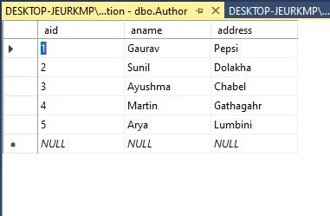

Book Table:

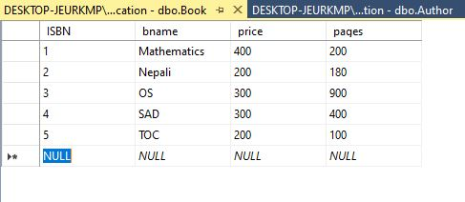

Reviewed Table:

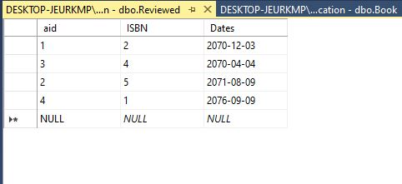

1.Create a stored procedure to find name and address of those author who writes books of price less

than 400.

create procedure Author_detail

AS

BEGIN

SELECT aname,address

FROM author

where aid in(select aid from reviewed

where ISBN IN(SELECT ISBN FROM BOOK

WHERE PRICE<400))

END

GO

;

Exec Author_detail

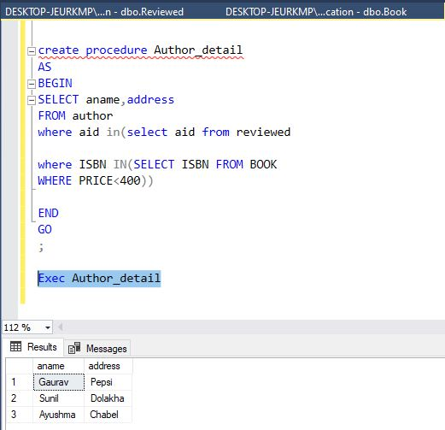

2.Create a stored procedure that to find name pf books of price greater than 200.

CREATE PROCEDURE Author_details

AS

BEGIN

SELECT bname,price

FROM Book

where price>200

END

GO

;

Exec Author_details

